DEPARTMENT OF BASIC SCIENCES AND ISLAMIAT
University of Engineering and Technology, Peshawar

PAPER: Linear Algebra (BSI-111)
Final -Term Examination 3rd semester Fall-2020
( Computer system Engineering)
Time Allowed: 3 hours Max Marks: 50
Note: Attempt all questions:
Q1 CLO-1, Cognitive Domain, PLO-2, Taxonomy Level-2 (6+6)
(a) Let 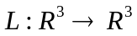be the linear transformation defined by
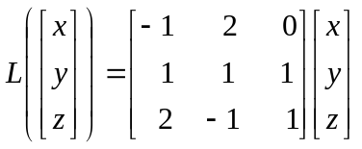. Is 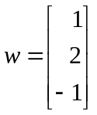 in range L?
(b) Find all constants a such that the vectors (a, 2) and (a,-2) are orthogonal.
Q2. CLO-1, Cognitive Domain, PLO-2, Taxonomy Level-2 (7+7)
(a) Determine whether the given set together with the given operations is a vector
Space. The set of all positive real numbers with the operations 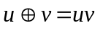
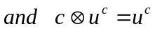.
(b) Determine whether the given subset of 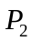is a subspace.
The set of all Polynomials of the form
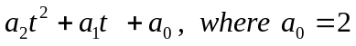
Q3. CLO-2, Cognitive Domain, PLO-1, 2 Taxonomy Level-3 (6+6)
(a) Discuss basis for a vector space.
(b) Does the following set of vectors form a basis for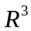?
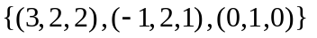
Q4. CLO-2, Cognitive Domain, PLO-1, 2 Taxonomy Level-3 (6+6)
(a) Discuss the Characteristic polynomial, eigenvalues, and eigenvectors of the matrix
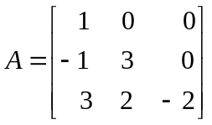
(b) Find a 2x2 nondiagonal matrix whose eigenvalues are 2 and -3, and respective
Eigenvectors are
